User Guide — The Scholar

The Scholar — User Guide

Overview
The Scholar is a personal research assistant that helps you organize documents into notebooks, ask questions and receive answers with precise citations from your provided sources, along with a Studio toolkit that transforms documents into reports, mind maps, flashcards, quizzes, and more — without fabricating information beyond the sources.
──────────────────────────────────────────────────

Interface Layout
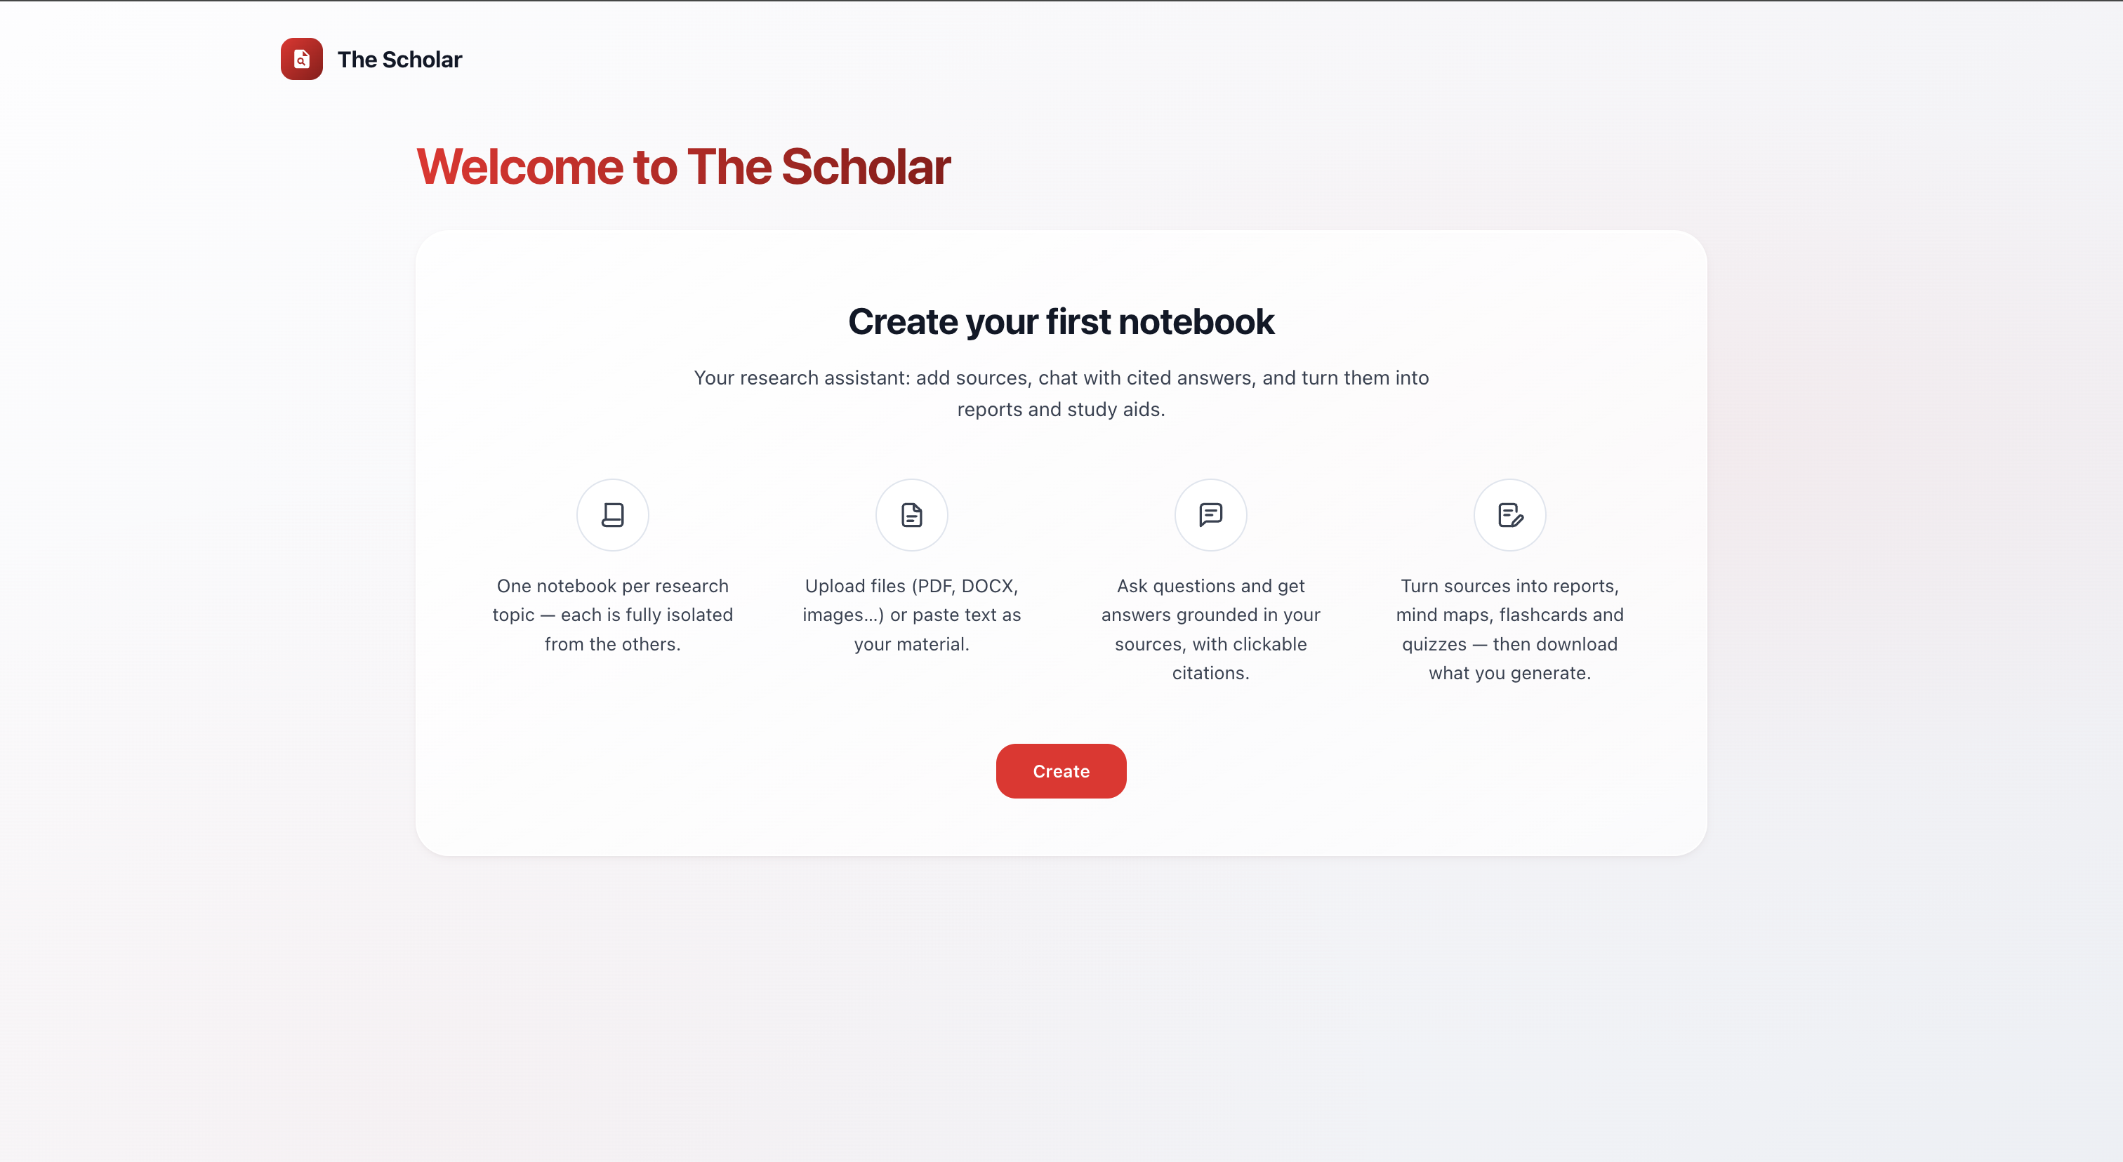
3-column interface: Sources (left) · Chat (center) · Studio (right)
When entering a notebook, the screen is divided into 3 areas:
Area | Purpose
Left (Sources) | List of sources added to the notebook; add source button (Upload file / Paste text); select/deselect sources to limit answer scope
Center (Chat) | Question input field, initial quick suggestions, cited answers with clickable references, and follow-up suggestions
Right (Studio) | 6 tools to generate outputs from sources (Report, Mind Map, Flashcards, Quiz, Data Table, Infographic) + Notes
Before entering a notebook, you’ll see the Hub — an overview page showing all your notebooks and notebooks shared with you.
──────────────────────────────────────────────────

How to Use

Step 1: Create a Notebook
From the Hub, click Create Notebook. Each notebook is a separate research space — sources in one notebook are completely isolated from others.
You can choose a pre-made template or start with a blank notebook: - Literature review - Study guide - Meeting notes - Blank

Step 2: Add Sources
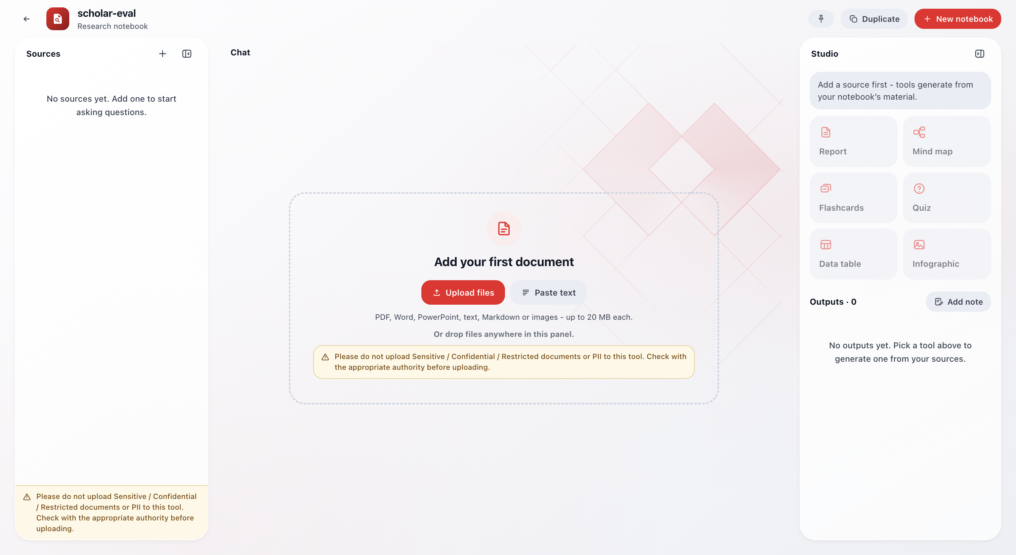
Sources panel with status indicators: green dot (ready) and yellow dot (processing)
There are 2 ways to add sources:
Method | Description
Upload file | Select a file from your computer. Supported: PDF, DOCX, PPTX, TXT, MD, JPG, PNG — max 20 MB per file
Paste text | Copy-paste content directly — max 480,000 characters
After adding, a source will be in Processing state (yellow dot) → the system analyzes, chunks, and indexes it. When complete, it changes to Ready (green dot). If there’s an error → Unreadable (red dot), you can retry processing.

Step 3: Chat
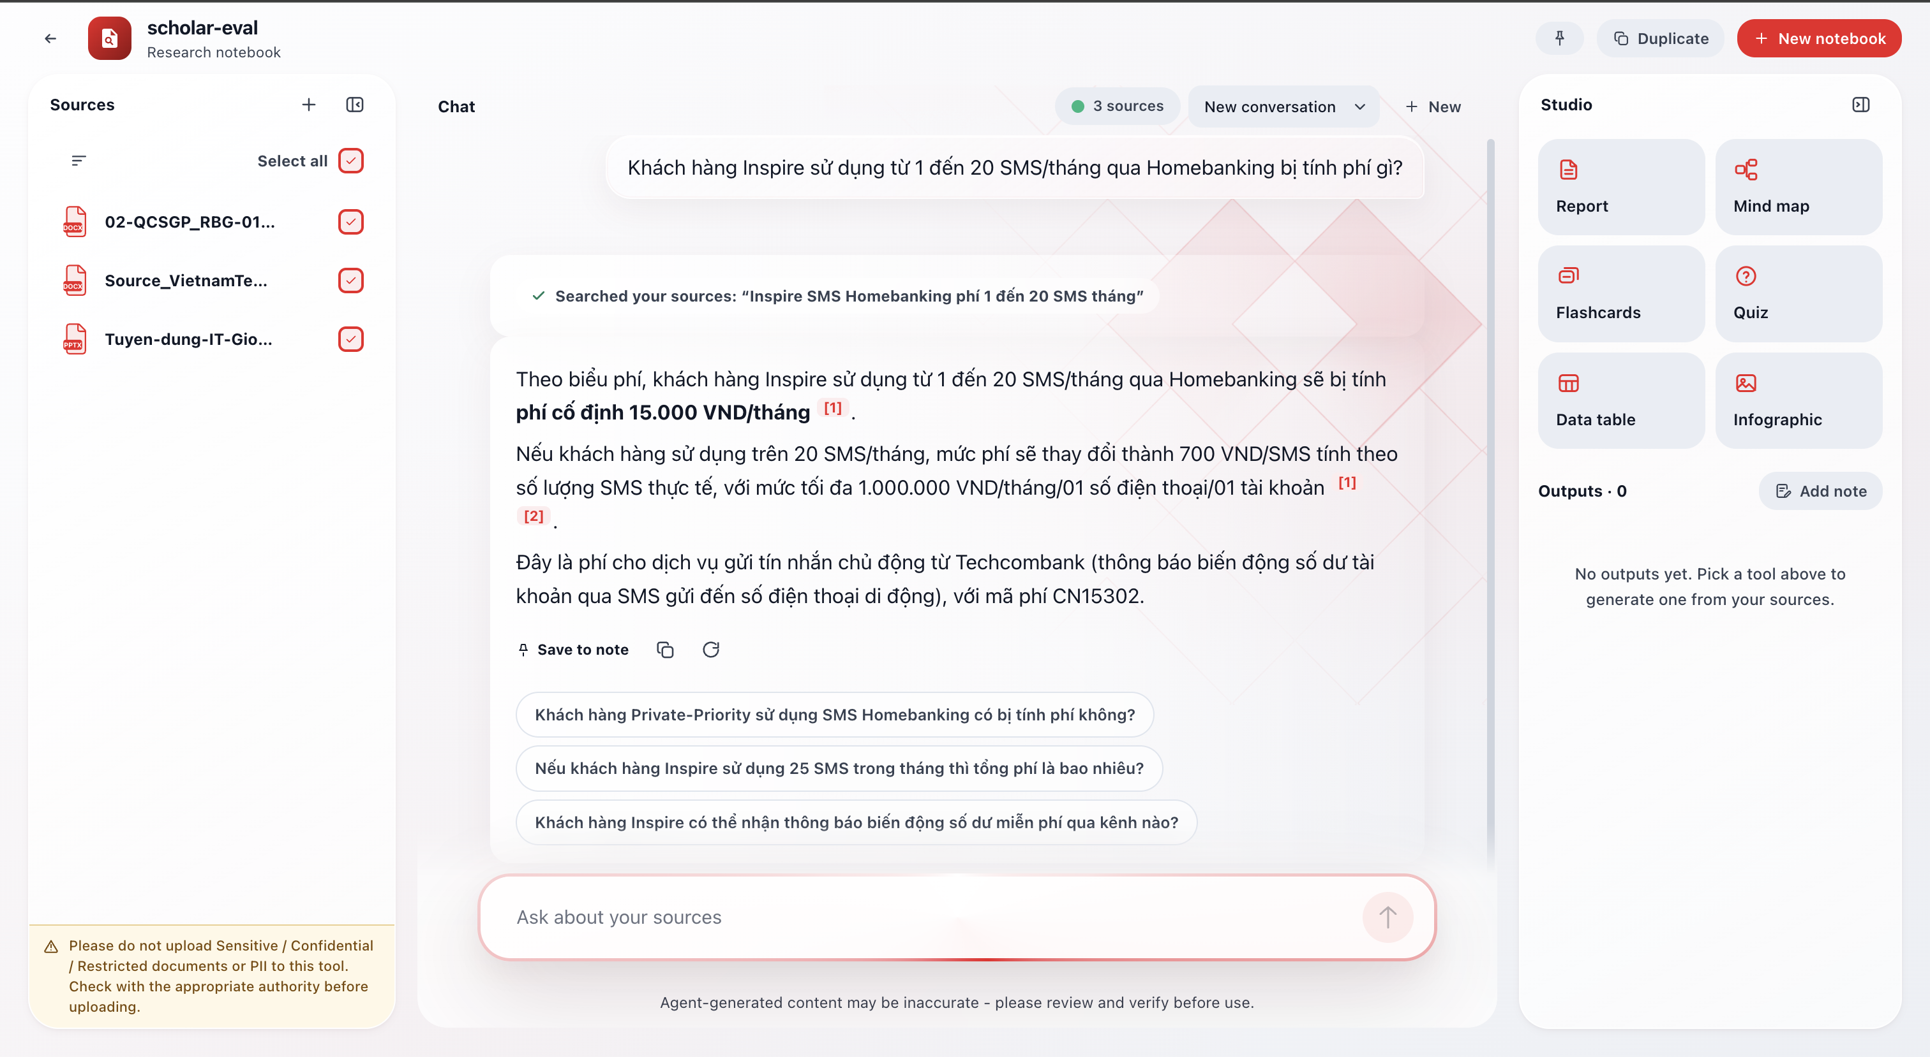
Answer with citations [1][2] and 3 follow-up suggestions
Ask questions about your documents. The Scholar will: - Search within selected sources - Answer with citations [1], [2], … — click a citation to view the original passage - Suggest 3 follow-up questions

Step 4: Use Studio to Generate Outputs
Select a tool in Studio to transform sources into structured outputs — see details in the Studio section below.
──────────────────────────────────────────────────

Sources Panel
- Add source: click the “+” button → choose Upload file or Paste text
- Select/deselect sources: tick/untick individual sources to limit answer scope. Newly added sources are automatically selected
- View source: click a source name to open the reader, which includes extracted content and the original file (if available)
- Delete source: open the “…” menu → Delete source (cannot be undone)
- Collapse: the panel can be collapsed into a rail showing source avatars, still clickable to select/deselect
──────────────────────────────────────────────────

Chat

How It Works
The Scholar classifies your questions and responds in the most appropriate way:
Question Type | Response Method
Asking about specific facts/information | Searches sources → answers with citations
Asking about notebook overview (“what’s in here?”) | Based on summaries of each source, no search needed
Casual conversation (“make it shorter”, “explain again”) | Processes context from the previous answer
Asking general knowledge outside sources | Answers with a clear warning that the information is not from your sources
Asking when no sources exist | Does not answer, guides you to add documents

Chat Features
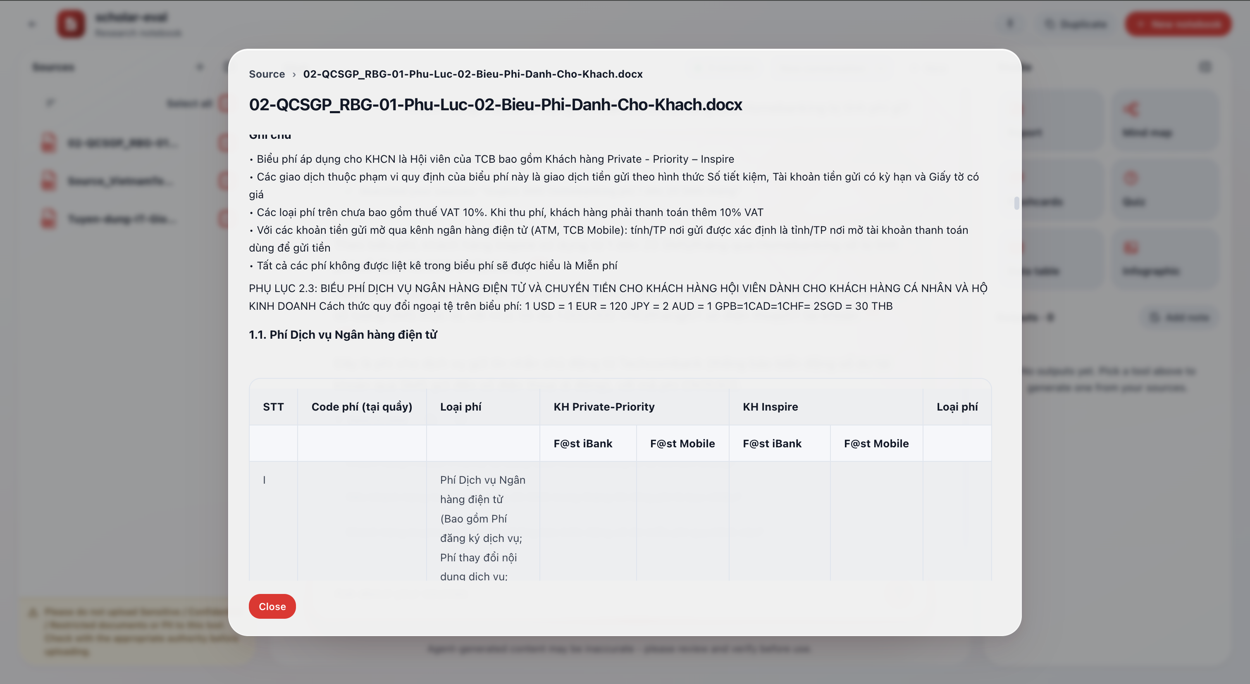
Source Reader opens when clicking a citation — original passage is highlighted
- Clickable citations: each [n] in the answer is clickable to view the original source passage
- Follow-up suggestions: 3 suggested questions appear at the end of each answer
- Regenerate: click the regenerate button if unsatisfied with an answer
- Stop: can stop mid-generation if the answer is too long
- Save to notes: save useful answers to the Notes section in Studio
- Multiple conversations: create new conversations within the same notebook, each with its own history

Tips for Effective Questions
- Be specific: “Summarize Q2 financial metrics from the annual report” is better than “Summarize”
- Select the right sources: deselect irrelevant sources for more focused, faster answers
- Use quick suggestions on the start screen to get started
- Use the 3 follow-up suggestions after each answer to dig deeper
──────────────────────────────────────────────────

Studio — Output Generation Tools
Studio includes 6 tools that transform your sources into structured outputs:
Tool | Description | Export Format
Report | Write a report in 7 preset formats or custom description | Markdown
Mind Map | Visualize key ideas as a branch diagram | PNG, SVG, XMind
Flashcards | Flip cards to memorize important information | Markdown
Quiz | Multiple-choice questions for self-assessment | Markdown
Data Table | Extract structured data into comparison tables | CSV
Infographic | Generate an infographic summarizing content | PNG

Customizing Each Tool
Report:
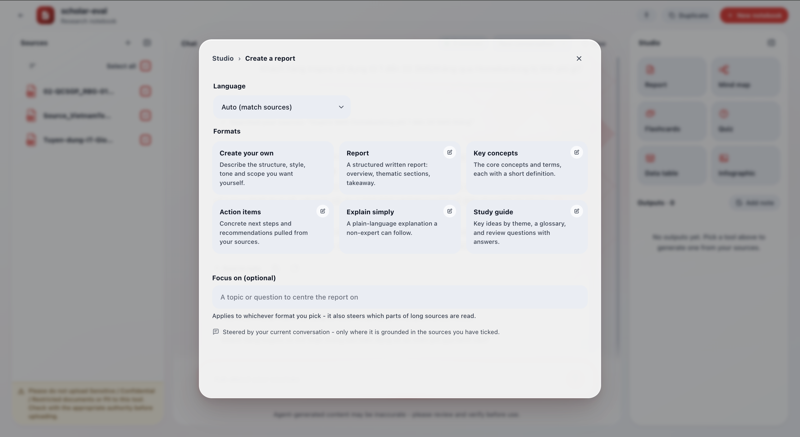
Report format picker — 7 formats + optional focus field
- Choose 1 of 7 formats: Custom description · Report · Key concepts · Action items · Simplified explanation · Study guide · Blog post
- Can edit instructions before generating
- Add optional focus topic
Mind Map:
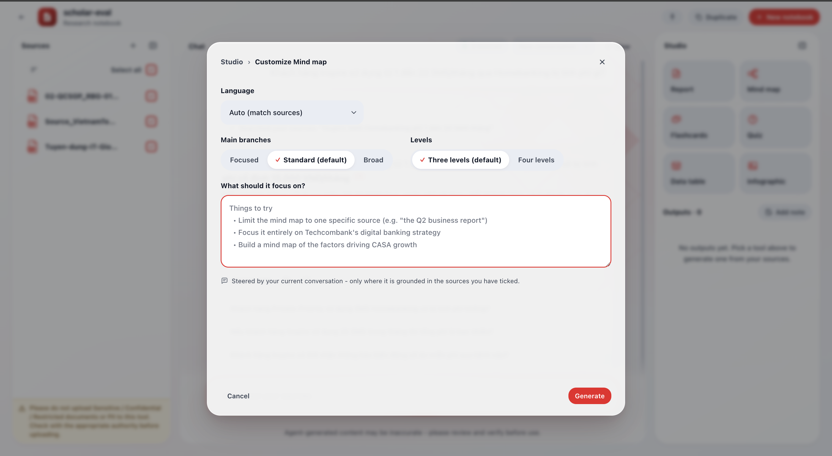
Mind map viewer — visual branch diagram, collapsible branches
- Number of branches: Condensed (3–4) · Standard (4–6) · Comprehensive (6–8)
- Depth levels: Three levels · Four levels
- Language
Flashcards / Quiz:
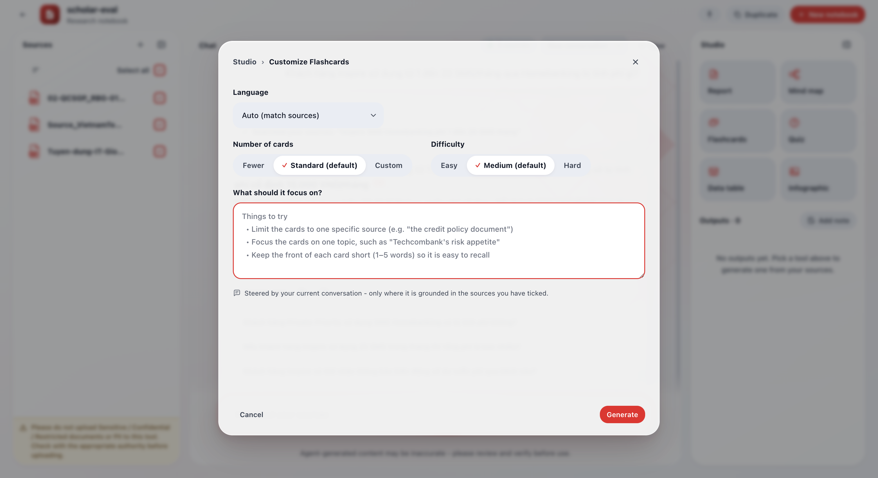
Flashcard viewer — click a card to flip
- Quantity: Fewer · Standard · Custom (up to 50)
- Difficulty: Easy · Medium · Hard
Infographic:
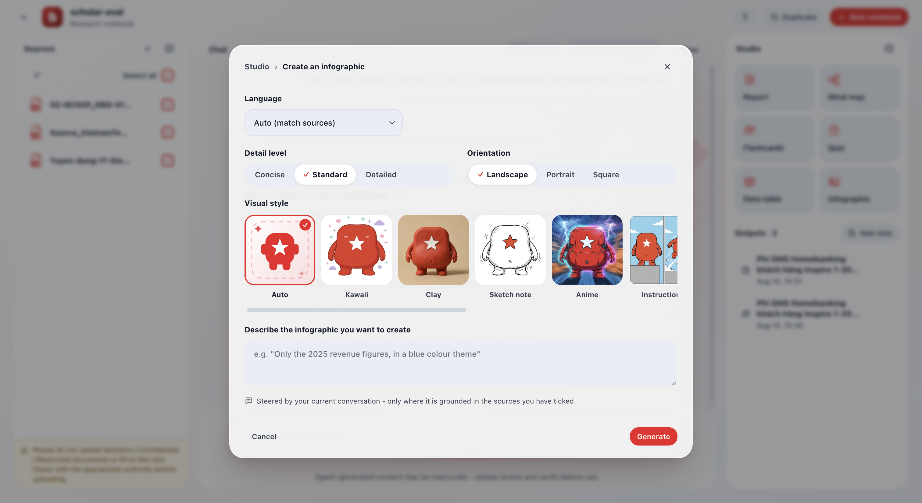
Infographic modal — choose style, orientation, detail level
- 11 visual styles (auto, kawaii, clay, sketch note, anime, etc.)
- Orientation: Landscape (1536×864) · Portrait (864×1536) · Square (1024×1024)
- Detail level: Condensed · Standard · Detailed (beta)
- Custom description
Data Table: - Language - Describe the table you want (e.g., “Create a product comparison table by fees, benefits, and conditions”)

Viewing & Managing Results
- Results appear in the Studio list → click to view details
- Rename: click “…” → Rename
- Download: depends on type — PNG/SVG/XMind for mind maps, CSV for data tables
- View recipe & sources: review how the result was created — includes selections, sources read, and instructions
- Delete: click “…” → Delete

Studio Result Detail Views

Report — Detail Viewer
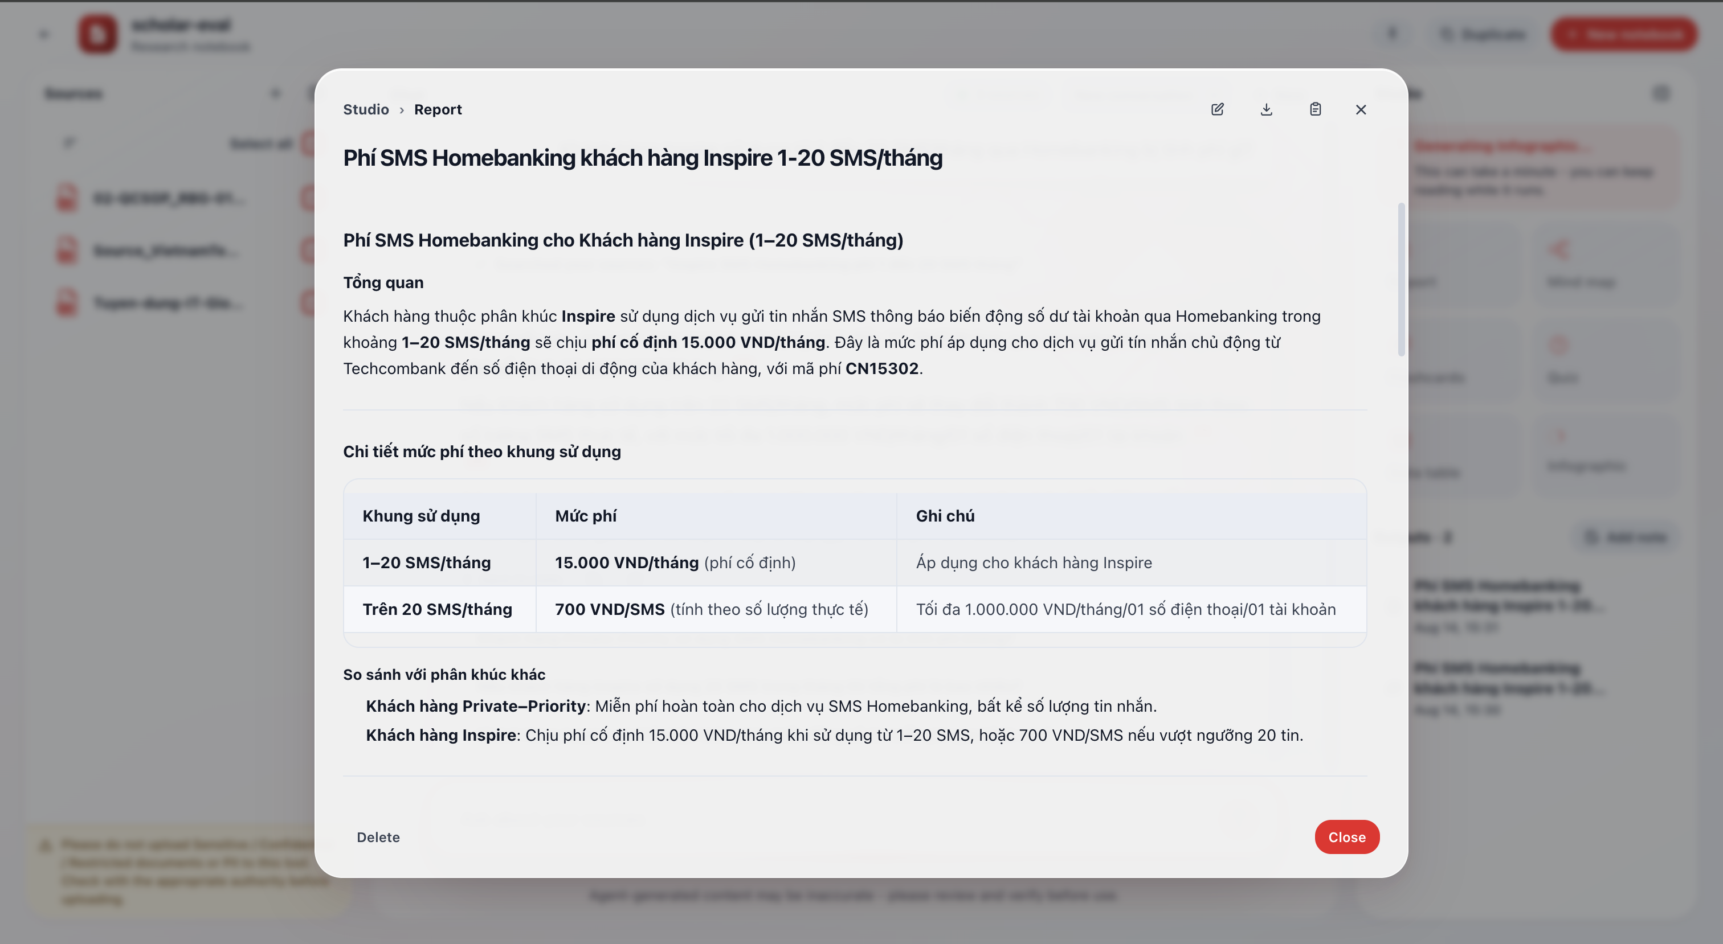
Report detail viewer — modal showing structured Markdown report
When clicking a report in the Studio list, a detail modal opens with:
Breadcrumb: Studio › Report — indicates the result type being viewed.
Toolbar (top right):
Icon | Function
✏️ Edit | Open edit mode for the report content
⬇️ Download | Download the report as a Markdown file
🗑️ Delete | Delete the result from Studio
✕ Close | Close the modal and return to workspace
Report content: displayed as structured Markdown text — includes headings, paragraphs, data tables, lists, and clearly delineated sections. The report renders directly in the modal, scrolling vertically for long content.
Bottom buttons: - Delete (left): delete the result - Close (right): close the modal

Mind Map — Detail Viewer
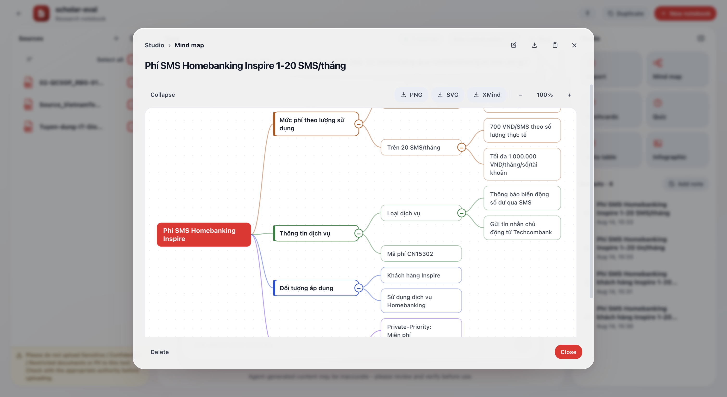
Mind map detail viewer — branch diagram with export toolbar and zoom
When clicking a mind map in the Studio list, a detail modal opens with:
Breadcrumb: Studio › Mind map
Toolbar (top right): Edit · Download · Delete · Close (same as Report).
Diagram controls (above content):
Button | Function
Collapse | Collapse all child branches
⬇️ PNG | Export diagram as PNG image
⬇️ SVG | Export diagram as SVG vector
⬇️ XMind | Export as XMind file for the XMind app
− / + | Zoom out / Zoom in
100% | Shows current zoom level
Diagram content: displayed as a visual tree: - Root node (red) on the center-left — contains the main topic - Level 1 branches (colored frames) — key ideas - Level 2, 3 branches — details breaking down from parent branches - Each branch has a ⊖ button to collapse/expand child branches - Can pan (drag) and scroll to navigate large diagrams
Bottom buttons: Delete · Close

Flashcards — Detail Viewer
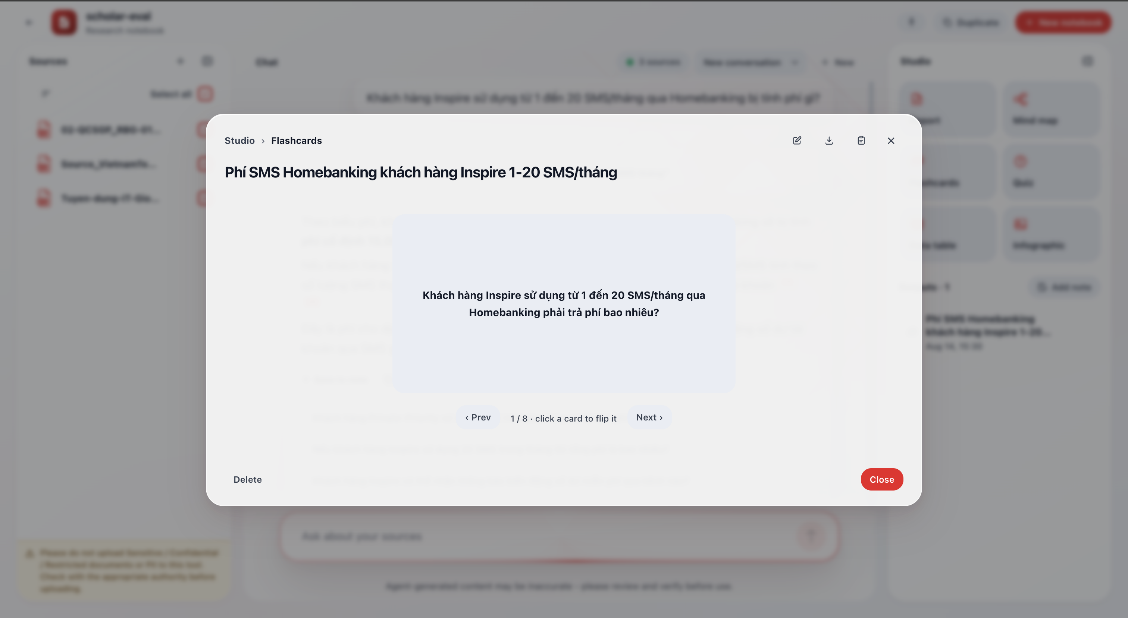
Flashcard detail viewer — flip card with Prev/Next navigation
When clicking a flashcard set in the Studio list, a detail modal opens with:
Breadcrumb: Studio › Flashcards
Toolbar (top right): Edit · Download · Delete · Close (same as Report).
Card content: - Displays one large card in the center of the modal with a question (front) or answer (back) - Remaining cards appear blurred on both sides (left/right) creating a carousel effect - Click the card to flip — view the answer on the back
Navigation bar (below cards):
Element | Function
‹ Prev | Go to previous card
1 / 8 · click a card to flip it | Current card number / total cards + flip instruction
Next › | Go to next card
Bottom buttons: Delete · Close

Infographic — Detail Viewer
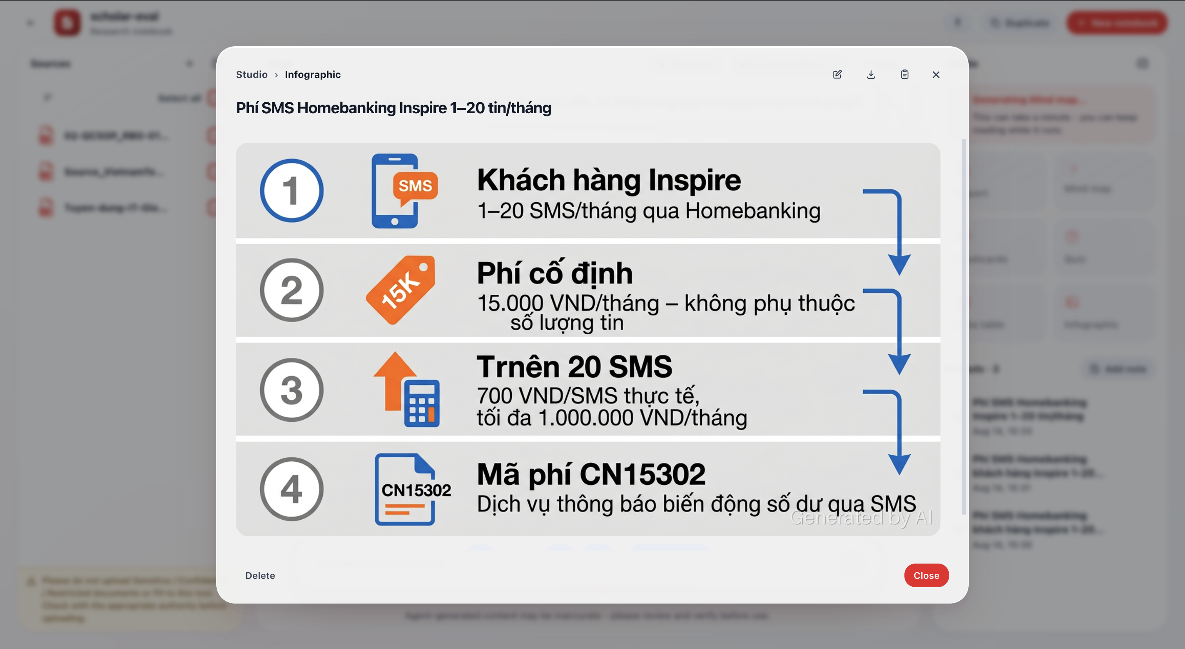
Infographic detail viewer — AI-generated infographic image
When clicking an infographic in the Studio list, a detail modal opens with:
Breadcrumb: Studio › Infographic
Toolbar (top right): Edit · Download · Delete · Close (same as Report).
Infographic content: - Displays an AI-generated infographic image — summarizes source content into a visual format - The image has a clear layout: numbered steps, illustrative icons, large headings, and brief descriptions for each point - Visual style depends on the choice made during creation (flat, kawaii, clay, sketch note, etc.) - “Generated by AI” watermark in the bottom-right corner - Scrolls vertically if the image is portrait or larger than the modal frame
Bottom buttons: Delete · Close

Notes
- Click Add note in Studio to write free-form notes
- Or click Save to notes on a chat answer to save it
──────────────────────────────────────────────────

Hub — Overview Page
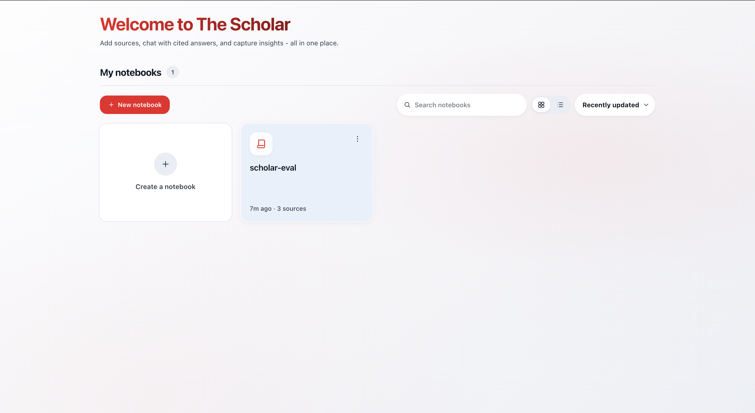
Hub — notebook grid list with quick stats
The Hub displays: - My notebooks: notebooks you own - Shared with me: notebooks others have shared (read-only) - Continue: return to the most recent notebook - Quick stats: number of sources, notes, conversations
On first visit, you’ll see a 4-step onboarding journey introducing how to use The Scholar: 1. Create a notebook — one notebook per topic 2. Add sources — upload files or paste text 3. Chat — ask questions, get cited answers 4. Generate outputs — transform sources into reports, mind maps, etc.
──────────────────────────────────────────────────

Language
The Scholar supports Vietnamese and English: - Interface language follows the selection on the TAI Studio toolbar - Chat answers automatically match the language of your question (not the source language) - Studio outputs can have a separate language setting: Follow source / English / Vietnamese
──────────────────────────────────────────────────

Tips
- Be specific — “Compare Q1 and Q2 revenue in the financial report” yields better results than “Compare numbers”
- Select the right sources — deselect irrelevant sources for more focused, faster answers
- Use separate notebooks for each topic — sources are completely isolated between notebooks
- Combine Chat + Studio — chat to understand documents, then use Studio to create outputs (Studio results will be guided by the current conversation)
- Add a notebook description — a general description/context helps overview answers be more accurate
- Download results — mind maps export as PNG/SVG/XMind, data tables export as CSV
- Save notes — save good answers to notes so information isn’t lost in long conversations
──────────────────────────────────────────────────

Limitations
- The Scholar only answers based on sources you provide in the notebook — it does not fabricate information
- Does not support adding sources via URL/link — you need to upload files or paste content
- Right after adding a source, wait a few seconds for indexing to complete before search works fully
- Max 20 MB per file; pasted text max 480,000 characters
- JSON-based Studio outputs (mind maps, flashcards, quizzes, tables) depend on model output quality — sometimes regeneration is needed
- Answers may not always be accurate — always verify important information by clicking citations to read the original source
- Does not provide medical, legal, or personal financial advice
- ⚠️ Please do not upload Sensitive / Confidential / Top Secret documents. Check with the appropriate authority before uploading
──────────────────────────────────────────────────
Last updated: 14/08/2026

